Setting up Qt Creator for BBB development

Creating a QtCreator Kit for the BeagleBone Black

After you have installed the Akna SDK and have run setupSSHKey.sh, you are ready to set up Qt Creator to develop and cross-compile Qt applications for the BeagleBone Black.
In order to create Qt applications and cross-compile them for the BeagleBone Black, you first have to create what Qt Creator refers to as a “kit”. In the Debian Buster PC or VM, open Qt Creator by selecting Applications | Programming | Qt Creator.

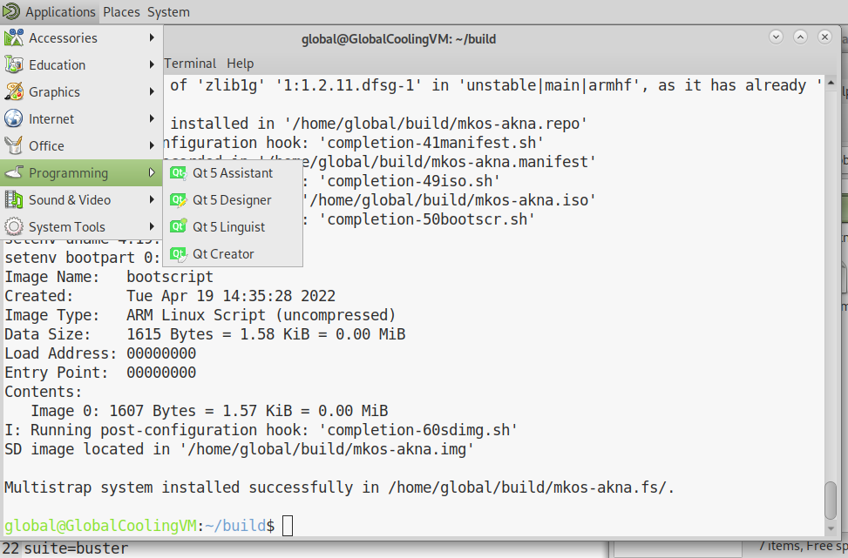

Go to Tools | Options
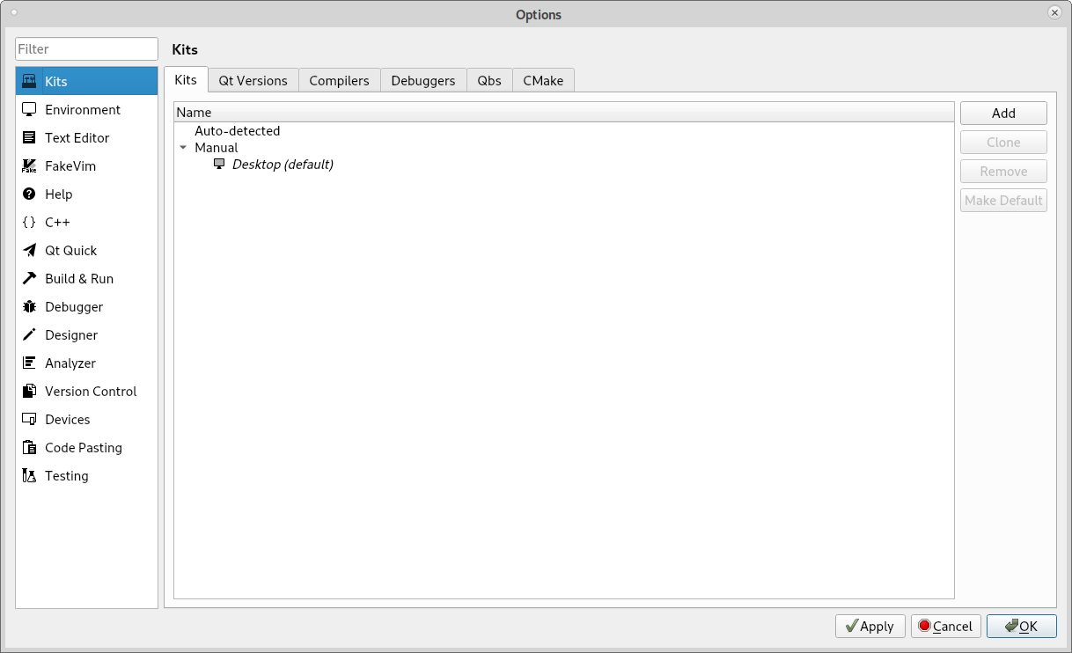

Make sure Kits is selected in the left hand pane. Click the Add button in the right hand pane.
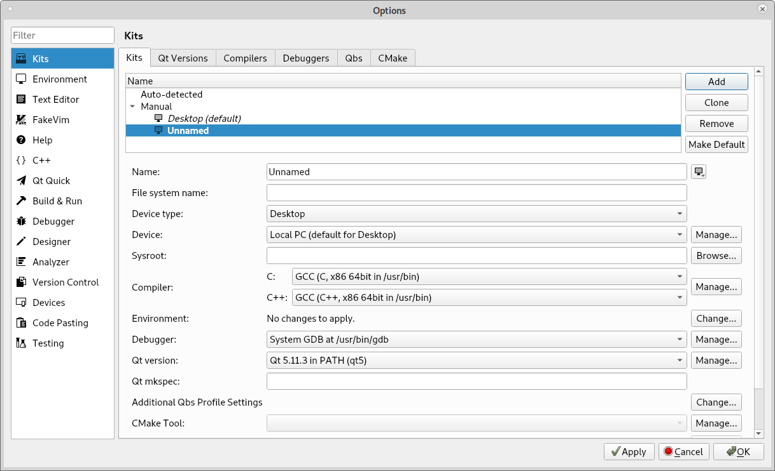
Edit the "Name:" field. Change it from "Unnamed" to "BeagleBone Black".
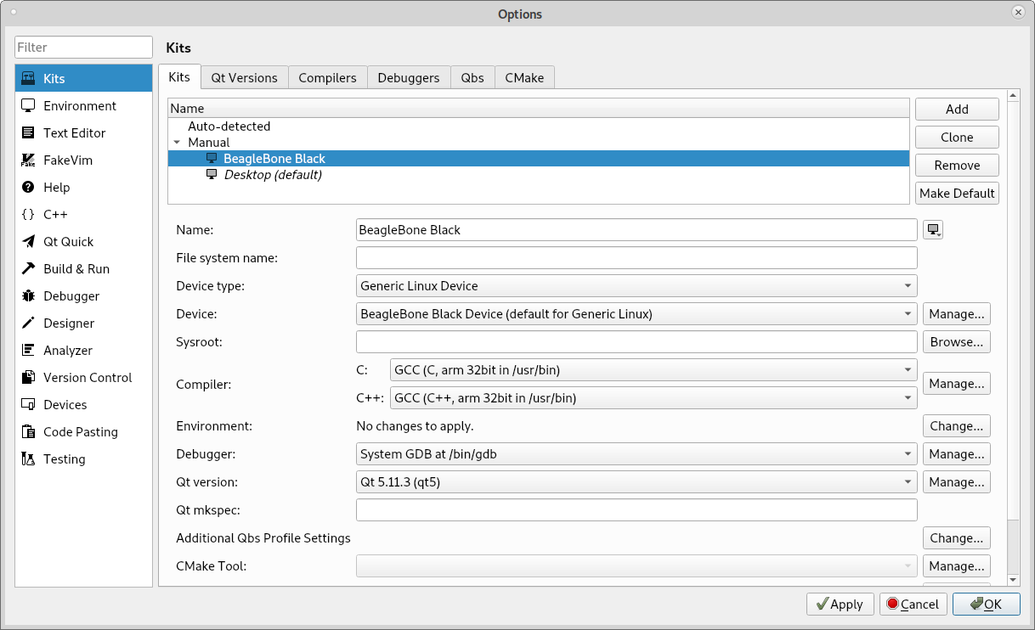

In the "Device type:" dropdown, select "Generic Linux Device"
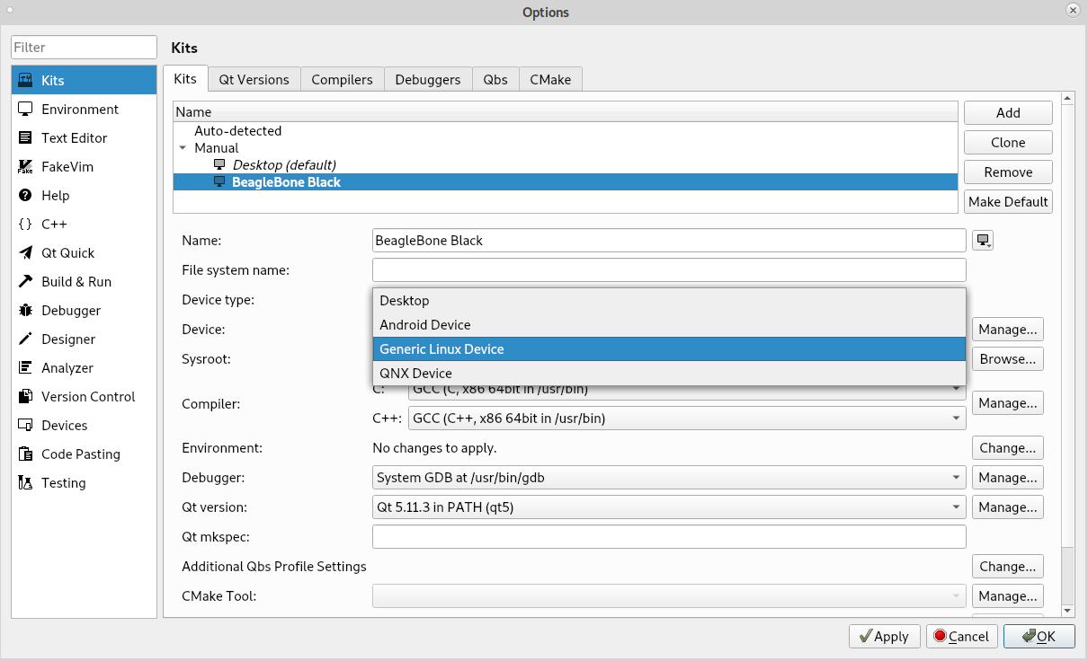
For the C and C++ compiler, click the dropdown for each and select GCC (C arm 32bit in /usr/bin) for the C compiler, and GCC (C++ arm 32bit in /usr/bin) for the C++ compiler, respectively.

Click the "Manage..." button on the far right in the "Device:" row.
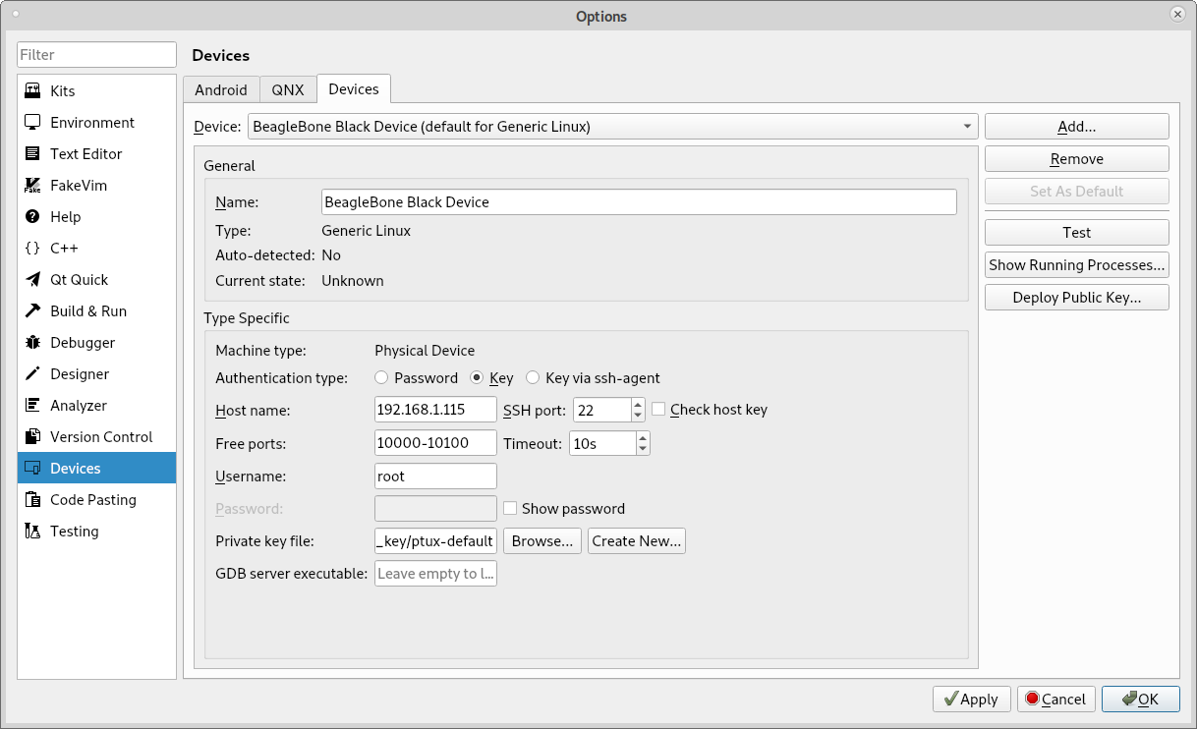

Enter the IP address of the BeagleBone Black you want to manage in the box labelled “Host name:” Click the “Browse..” in the “Private key file:” row. Browse to ~/.ssh and double click the ptux-default file. Click the Apply button at the bottom of the Options dialog box, then click the Test button at the right hand side of the Options dialog box. The following Device Test box will be displayed:
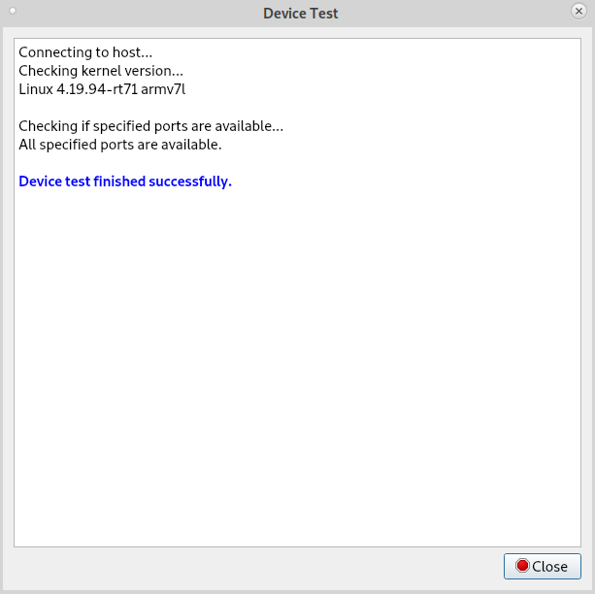

If the Device Test finished successfully, then you can click Close for the Device Test dialog, and Ok for the Options dialog. You have completed the setup of Qt Creator for cross-compiling Qt applications for the BeagleBone Black.

